- 8-BIT DIVISION OPERATIONS USING 8085 MICROPROCESSOR
To write an ALP to perform division of two 8 bit numbers Stored in memory location

4200H, 4201 H and Store the remainder in 4202H and the quotient in 4203H.

APPARATUS REQUIRED:
  - 8085 microprocessor kit 1
  - Power card 1
  - Keyboard 1

ALGORITHM:
- Load the divisor in accumulator and move if to B-register
- Load the dividend in the accumulator.
- Clear C-register to account for quotient
- Check whether divisor is less than dividend
- If divisor is less than dividend, go to step 8, otherwise go to next step
- Subtract the content of B-register (quotient)
- Increment the content of C-register (quotient)
- Go to step 4
- Store the content of the accumulator (remainder) in memory.
- Move the content of C-register (quotient) to accumulator and store in memory
- Stop.

Output:
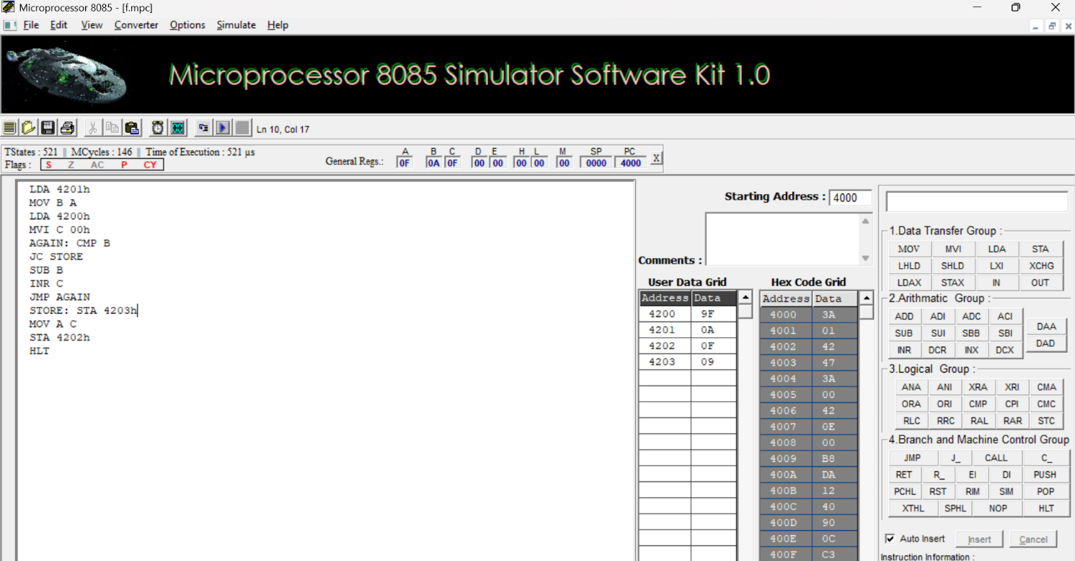
Result:
Divide two numbers of 8-bit data was written, executed and Verified the Result successfully using 8085 kits.

